Computer Vision Homework 6

Name: 黃新予

Student ID: f08922136

1. **Environment Setup  
   Language: Python 3 (on VS code)  
   Library: numpy, PIL**
2. 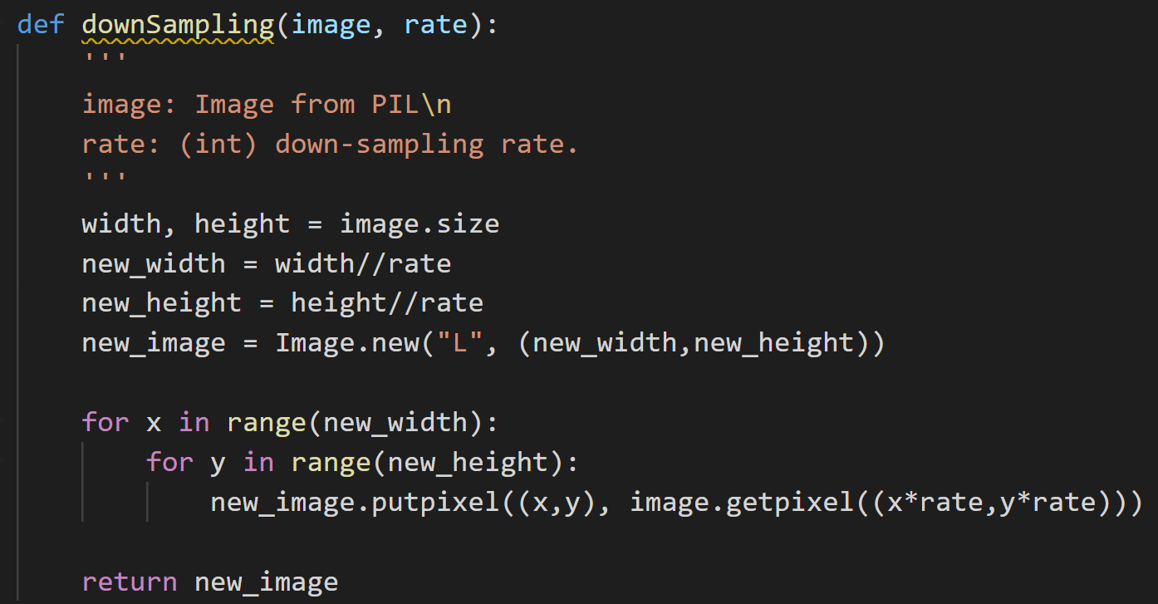Q1: Write a program which counts the Yokoi connectivity number on a downsampled image(lena.bmp).  
     
   step 1: down-sampling the original binarized lean.bmp from 512\*512 to 64\*64  
   step 2: implement Yokoi h function and f function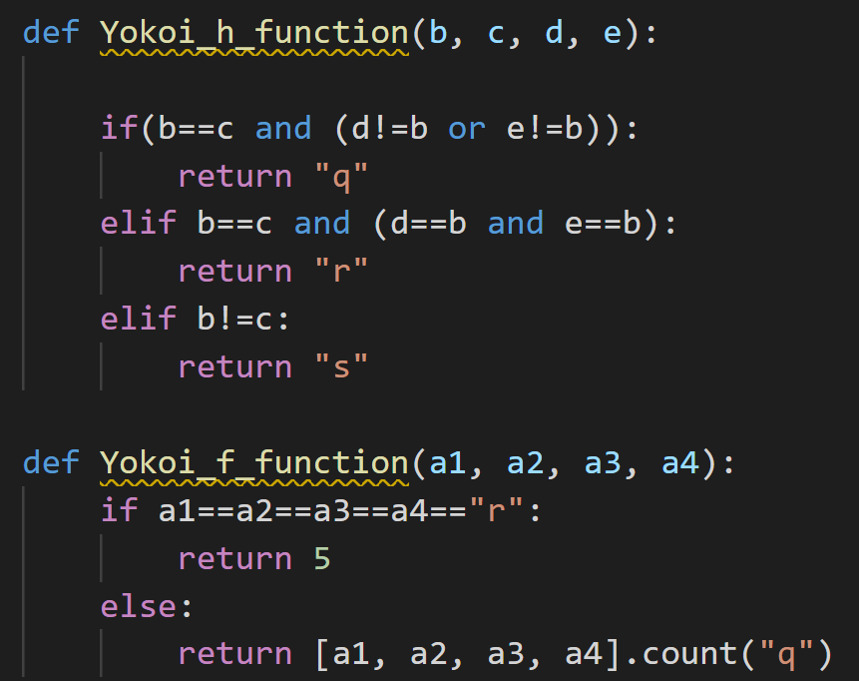  
     
     
   Step 3: traverse each element in the down-sampling image and count the connectivity number by h function and f function  
   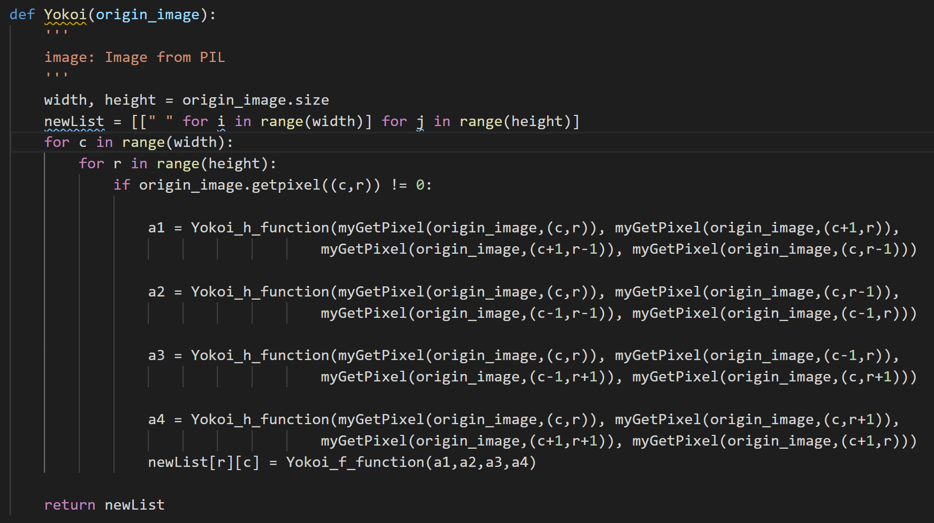  
     
   I also implement myGetPixel function to detect out of range problem.  
   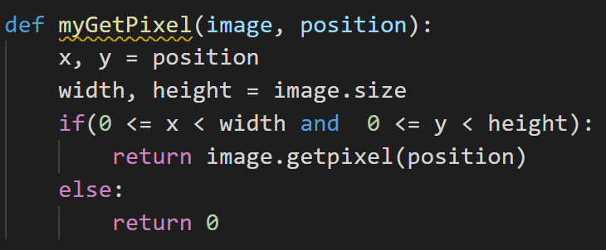  
   Step 5: write the output list to a txt file  
   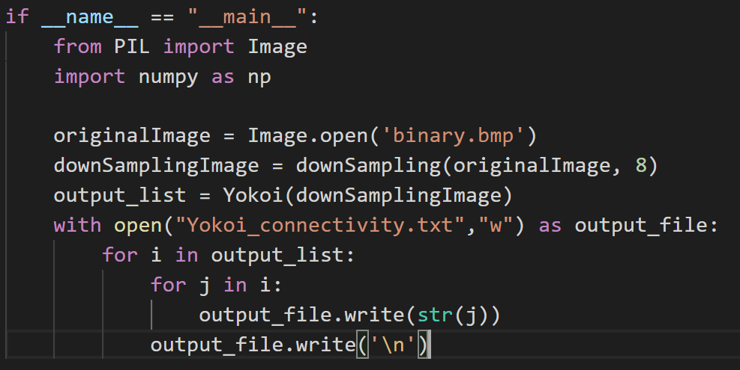  
     
   Result: 0s are also recorded.  
   